Linux installation guide

SiteSync

Document history 2

1 Introduction 3

2 Installing Linux on Atom board 3

2.1 Creating bootable USB drive 3

2.2 Installing Linux on Atom using bootable USB drive 7

3 Login into Atom board 15

# Document history

|  |  |  |
| --- | --- | --- |
| **Revision** | History | Date |
| 1.0 | First draft version | 07th April 2014 |

# Introduction

This document explains the process of setting up the DCU board. It is assumed that the DCU board is Atom ARK-1120 which doesn’t have any operating system on it. We would be using Ubuntu Linux distribution.

The document is divided into following parts:

1. Installing Linux on Atom board.
2. Login into Atom board.

# Installing Linux on Atom board

This section describes the steps for installation of Ubuntu on the Atom board. Following are the basic steps which are explained in detail later:

1. Creating a bootable USB drive.
2. Installing Linux on Atom using bootable USB drive.

## Creating bootable USB drive

This section gives the procedure to make a USB drive as bootable USB drive. Following are the steps to be followed:

1. You would require Windows 7 PC.
2. You would require 4 GB USB drive. **Please note that the USB drive will be formatted so you would lose content of the USB driver. Please take back up of the content if it is important.**
3. Download **POWER ISO** software for Windows 7 from <http://www.poweriso.com/download.htm>. You can select 32-bit or 64-bit based on your Windows 7 operating system.
4. Install POWER ISO software on Windows 7.
5. Download Ubuntu 12.04.1 version from <http://old-releases.ubuntu.com/releases/12.04.1/ubuntu-12.04.1-desktop-i386.iso>. This is **32 bit Ubuntu**. Copy it on the Windows 7 PC on which POWER ISO is installed.
6. Insert the USB drive you intend to make a bootable drive.
7. Reboot the PC.
8. On reboot, go to start menu and run POWER ISO executable as administrator. Following screen will be displayed.

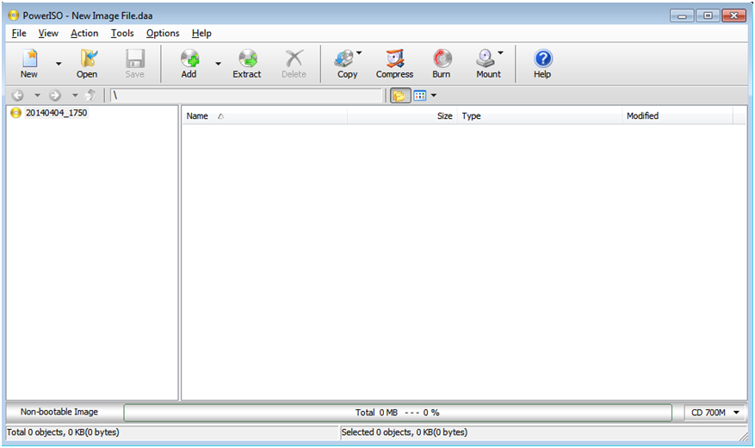

1. Select menu "Tools -> Create Bootable USB Drive". The "Create Bootable USB Drive" dialogs will popup.

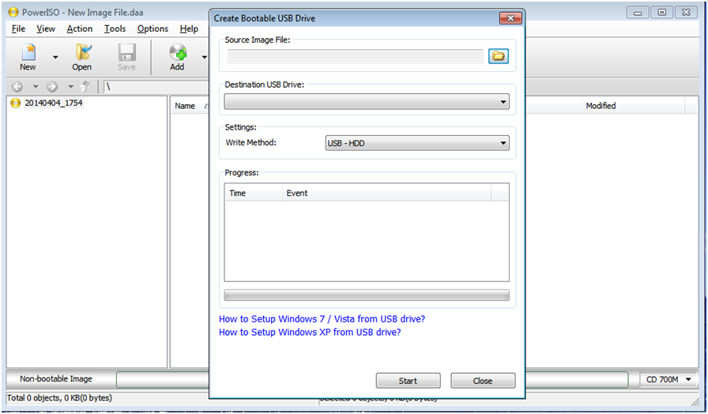

1. Under "Source Image File" select the Ubuntu image file downloaded from Internet.
2. Under "Destination USB Drive" select the USB drive attached to your PC.
3. Under "Write Method" select "USB-HDD".

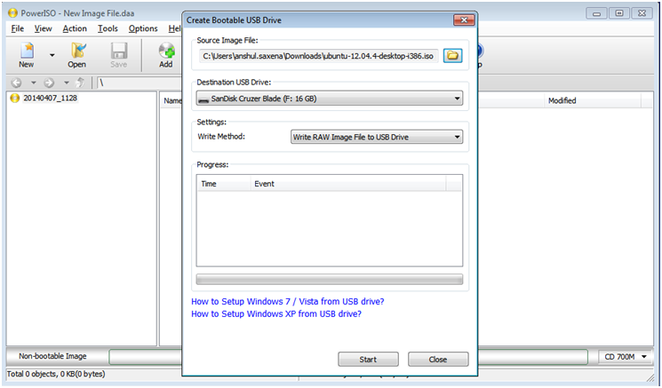

1. Click "Start" to initiate the process of creating bootable drive.
2. Writing progress will appear during creating bootable drive.

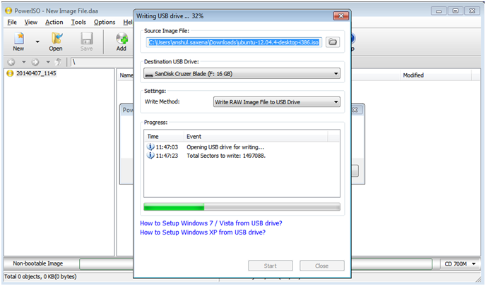

1. On completion utility will show message "Writing USB drive successful." as shown below.

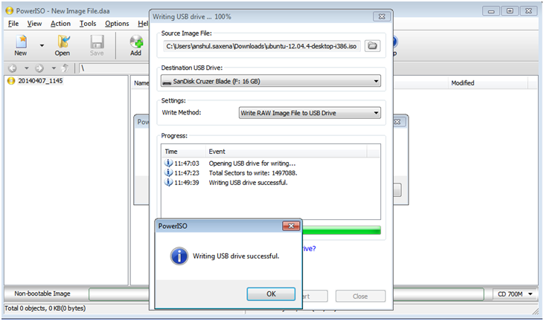

## Installing Linux on Atom using bootable USB drive

This section gives the procedure to install Linux to Atom board. Following are steps to be followed:

1. Insert the bootable USB drive (bootable USB drive created by following steps mentioned in section 2.1) into the USB port of Atom board and power it on.
2. On power on keep pressing F12 or F11 for boot device selection. If in case after pressing F12 or F11 the menu is not shown, then restart the device and press F2.
3. On display of menu option select the appropriate bootable USB drive.
4. On selection of USB drive the Atom board will start booting from the driver. It will show splash screen of Ubuntu. Ubuntu will load some settings and primary installation tools this might take couple of minutes.
5. Please ensure that the Ethernet cable is not connected to Atom board. This will ensure less time is taken while installation.
6. On completion of initialization following screen will be displayed. Select "Install Ubuntu" option.

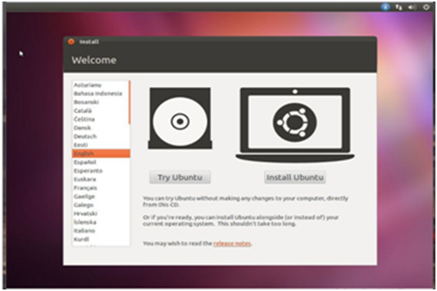

1. A screen regarding Internet connection, select the options as shown below and click "Continue".

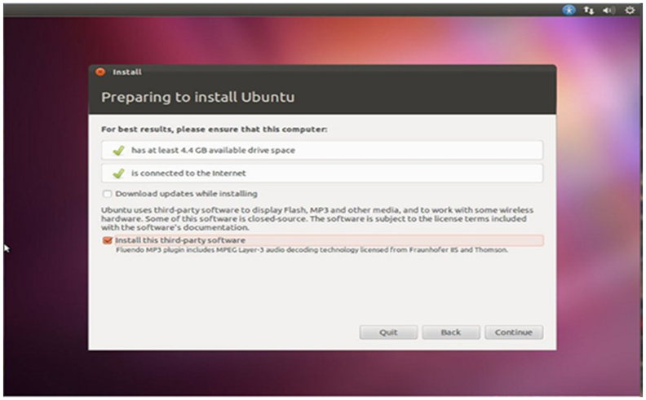

1. A screen will be displayed to select installation type. Select "Something else" option.

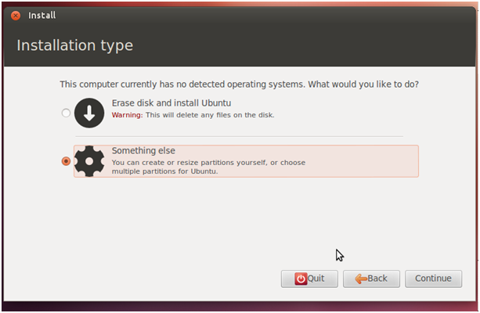

1. A screen will be displayed where you have to select the drive of Atom on which installation is to be carried out.

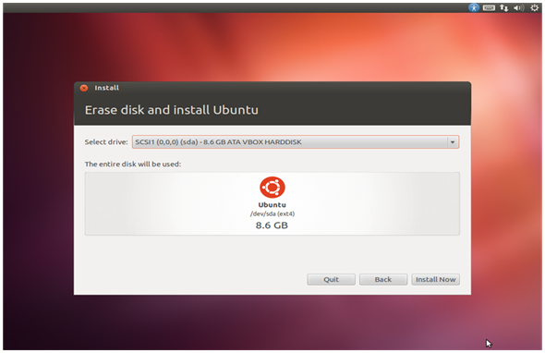

1. Once the drive is selected, then we have to prepare partitions on the driver. We have to create two partitions one as ‘/’ and another as ‘swap’. On the next screen similar to the one shown below select the driver **/dev/sda** and click the button "New Partition Table…".

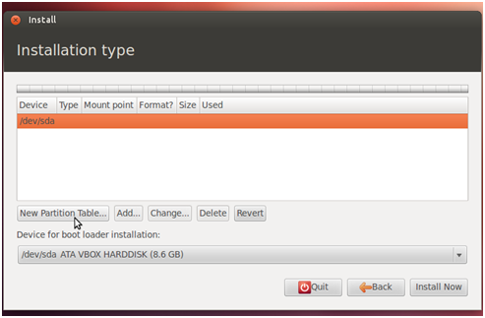

1. Click "Continue" on confirmation message.

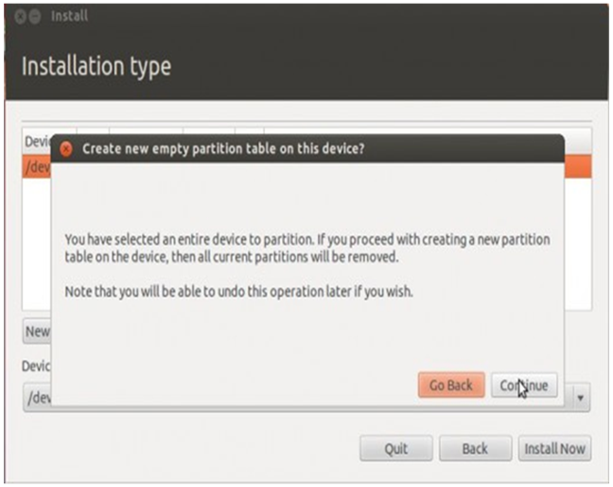

1. Fill the partition type as **Primary**, partition size as **6144**, location as **Beginning**, use as **Ext4** and mount point as **/**.

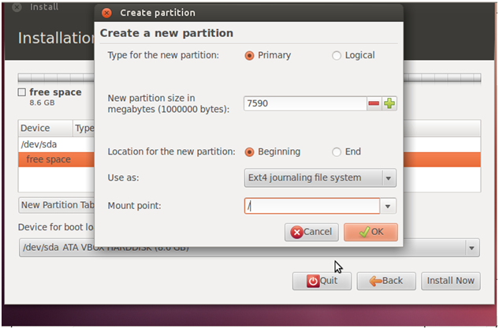

1. Once that ‘/’ partition is created then we have to create swap partition. Click on "Add" button to add swap partition.

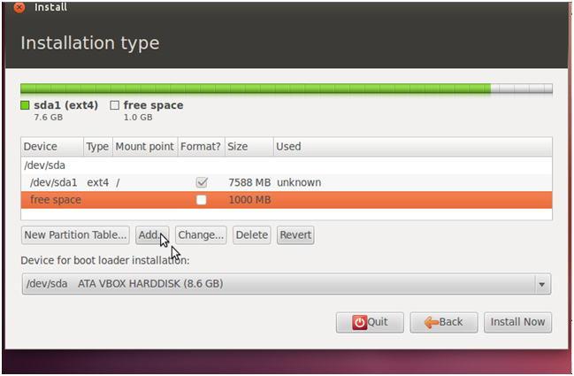

1. Fill the partition type as **Logical**, location as **Beginning**, use as **swap area** and mount point nothing. Don’t change partition size.

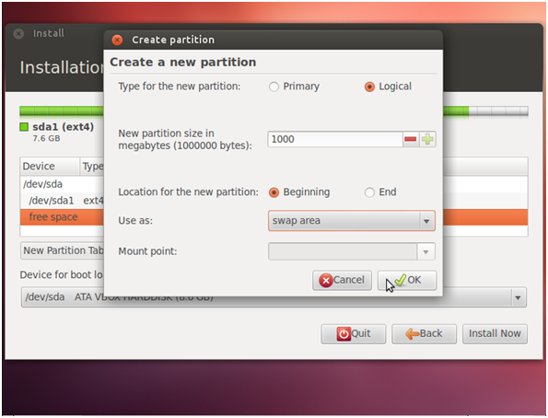

1. Once partition details are added, ensure that /dev/sda is selected in "Device for boot loader installation". Click on "Install Now" button.

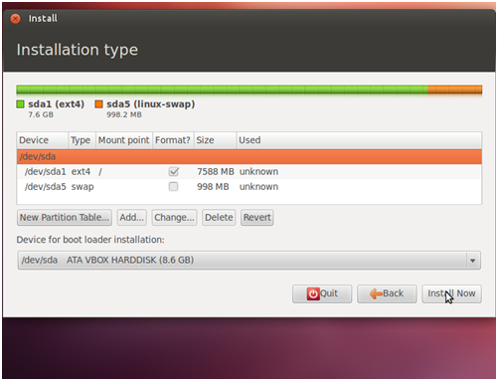

1. Select the geographical location and language.

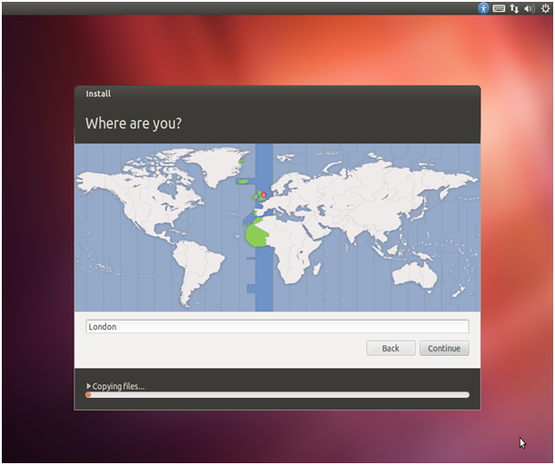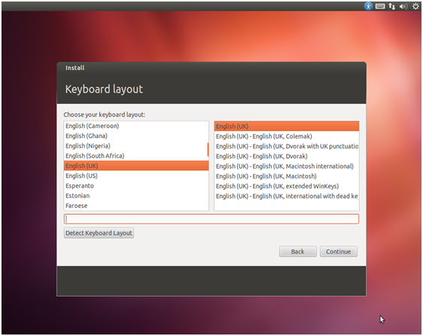

1. Please enter name, username and password as sitesync and press "Continue".

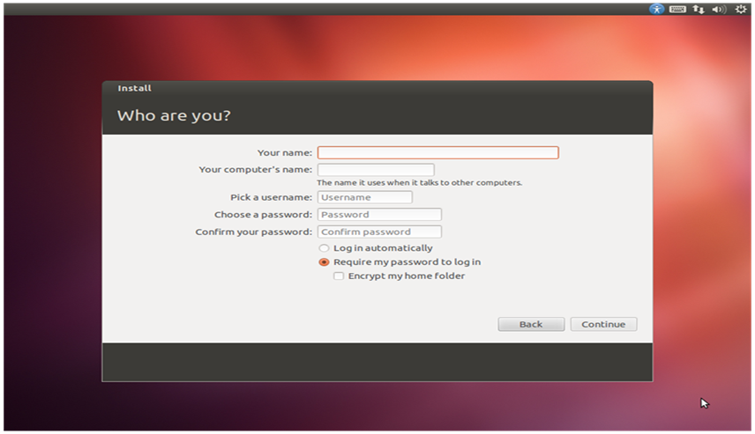

1. Following screen will display which will show the installation progress status.

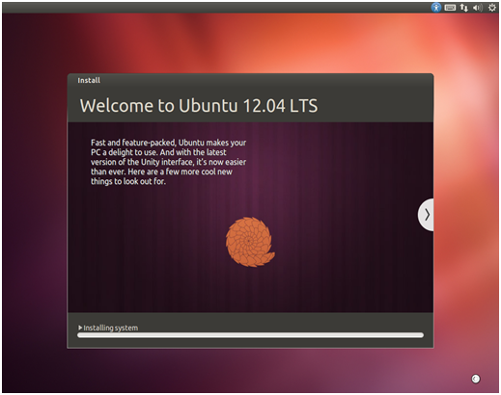

1. On successful installation a message will be displayed. The remove the USB driver and restart the board.

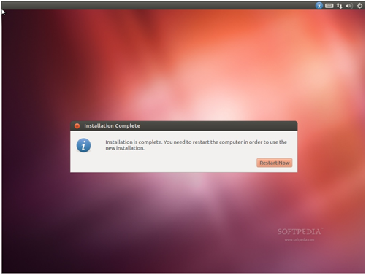

# Login into Atom board

Once the installation is completed and Atom board is rebooted. On reboot it will show login screen as shown below.

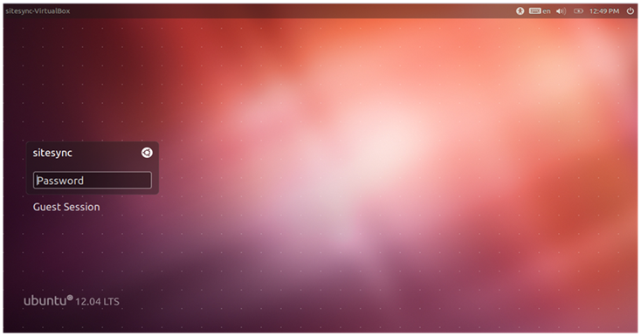

This is user interface mode of Linux. DCU application will run in command line mode. Press Ctrl + Alt + F1 to go on command prompt mode. Following login screen will be displayed on pressing the key sequence.

Ubuntu 12.04.1 LTS sitesync-desktop tty1

Sitesync-desktop login:

Enter user name and password as **sitesync**. On successful login a prompt will be displayed as shown below.

Ubuntu 12.04.1 LTS sitesync-desktop tty1

Sitesync-desktop login: sitesync

Password:

Last login: Mon Apr 7 23:51:38 IST 2014 on tty1

…………

…………

sitesync@sitesync-desktop:~$

To perform any activity you must be in administrative mode. To change the mode execute following command.

sitesync@sitesync-desktop:~$ sudo su

[sudo] password for sitesync:

root@sitesync-desktop:/home/sitesync#

After executing above command Linux will ask for password, enter sitesync as password. After this the prompt will change from **$ to #**.

This ensures that you now have permission to perform administrative actions.